**1.) Find the time complexity for the following scenarios**

**a.) for(i=1;i<=n;i++)**

**for(j=i;i<=n;j++)**

**printf("Hi");**

**Ans:**

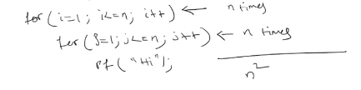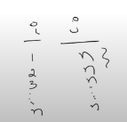

**b.) for(i=1;i<=n;i*=3)**

**for(j=1;i<=n;j++)**

**printf("Hello");**

**Ans:**